

WAD Lab Report

Course Title : Web Application Design Lab
Course Code : CSE0613124
Lab no. : 06
Topic : Using Page Layout Tags/Elements

Submitted to:
Teacher’s Name : Most. Thasin Sabira (MTS)
Designation : Lecturer

Submitted by:
Student Name : Gaus Saraf Murady
Student ID : 0432410005101088
Semester : Spring, 2025
Batch : 55
Department : CSE

Date of Submission: 16.03.25
Introduction
This is the Lab Report for Lab-06 of the Web Application Design course. In this lab, we learned about HTML Page Layout tags. We learned about many Layout Elements such as Header, Footer, Section, etc and Layout tags like Semantic and non-semantic tags. Here’s a brief explanation:
- HTML Page layout:
Tags used in the Lab:
There are multiple types of HTML Layout elements. We mostly learned about semantic tags,
  - <header></header> which defines a header for a document or a section.
  - <section></section> which defines a section in a document
  - <footer></footer> which defines a footer for a document or a section
  - <nav></nav> which defines a set of navigation links
Other tags and attributes:
  - We also learned about some CSS attributes like {margin:auto;}, which is an easy alternative for {justify-content:center;display:flex;} for centering a block of elements. It’s also easier than using <br> for vertical spacing and &nbsp for horizontal spacing
  - There are 2 non-semantic tags:
    - <div></div> which are used for styling a block of elements and
    - <span></span> which are used for inline styling

In this Lab Report Task, we needed to make an HTML page that uses Layout elements. We learned that these elements serve no real purpose other than creating meaningful page sections. Because they can be easily replaced with Div and Span tags.

Lab Work Code:

<!DOCTYPE html>
<html lang="en">

<head>
<meta charset="UTF-8">
<meta name="viewport" content="width=device-width, initial-scale=1.0">
<title>Lab 06</title>
<style>
a {
text-decoration: none;
color: black
}
</style>

</head>

<body style="background-color: rgba(0, 0, 0, 0.507);text-shadow: 1px 1px 5px black;">
<br>

<!-- <div style="justify-content: center;display: flex;"> -->
<header
style="background-color:rgba(7, 138, 253, 0.568);color: aliceblue;border-radius: 15px 15px 15px 15px;width:95%;margin: auto;">
<h2 style="margin:auto;text-align: center;padding:2%;">University of Information Technology
and
Sciences</h2>
</header>
<!-- </div> -->

<br>
<h1 style="color: aliceblue;justify-content:center; text-align: center;">Introduction about Nature</h1>

<!-- style="justify-content: center;display:flex" -->
<!-- INSTEAD WE CAN USE -->
<!-- margin: auto; -->

<table>
<tr>
<td
style="background-color: rgba(0, 0, 0, 0.37); background-image: url('tree.webp'); background-size:cover; padding: 10%; color: rgb(217, 255, 0); box-shadow: 0px 0px 10px 1px black; border-radius: 2%;margin: auto;width:80%;">

<div style="background-color: rgba(0, 0, 0, 0.233);">
<p>
<!-- <span style="outline:black; border: 1px solid black;"> -->
Nature is that natural and physical
world that surrounds us and makes life possible on earth. Nature is the heart of earth.
Nature heals us
and
helps build connection with our freedom, authenticity and our souls. Simply connecting and
feeling
nature
gives
us a divine pleasure. We have a strong bond and emotional connection with nature.
<br>
The serenity of nature calms our hearts. The stillness and movement in nature both have a
hypnotizing
effect.
The unfolding creativity of nature is an art. It is alluring to experience solitude with
nature. The
practice of
devoting ourselves to the bliss of nature is soothing and reviving. Everyone loves to escape
away in the
mysteries of nature.
<!-- </span> -->
</p>
</div>
</td>
</tr>
</table>

<br><br>

<section>
<h1 align="center" style="color: aliceblue;">Etymology</h1>
<article
style="background-color: aliceblue;color: rgb(0, 0, 0);padding: 2%; text-align: center;border-radius: 5px 5px 5px 5px;margin: auto;width: 80%;">
The word nature is borrowed from the Old French nature and is derived from the Latin word natura, or
"essential qualities, innate disposition", and in ancient times, literally meant "birth".[5] In ancient
philosophy, natura is mostly used as the Latin translation of the Greek word physis (φύσις), which
originally related to the intrinsic characteristics of plants, animals, and other features of the world
to
develop of their own accord.[6][7] The concept of nature as a whole, the physical universe, is one of
several expansions of the original notion;[2] it began with certain core applications of the word φύσις
by
pre-Socratic philosophers (though this word had a dynamic dimension then, especially for Heraclitus),
and
has steadily gained currency ever since.
</article>
</section>

<br><br>

<nav align="center"
style="background-color: aliceblue; padding: 5%; ; text-decoration: none;border-radius: 10px 10px 10px 10px; box-shadow: 1px 1px 10px black;justify-content:center;text-align: center; font-size: large; width: 80%;margin: auto;">
<a href="#">About</a>
&nbsp;&nbsp;&nbsp;&nbsp;
<a href="#">Contacts</a>
&nbsp;&nbsp;&nbsp;&nbsp;
<a href="#">FAQ</a>
&nbsp;&nbsp;&nbsp;&nbsp;
<a href="#">Copyright</a>
&nbsp;&nbsp;&nbsp;&nbsp;
</nav>

<br><br><br>

<footer>
<p
style="margin:auto;text-align: center;background-color: aliceblue;width: 80%;border-radius:5px 5px 5px 5px; padding: 2%;">
© 2022 University of Information Technology & Sciences (UITS). All Rights Reserved.
Developed and maintained by ICT Cell, UITS</p>
</footer>
<br>

</body>

</html>

File: tree.webp (I drew it myself)
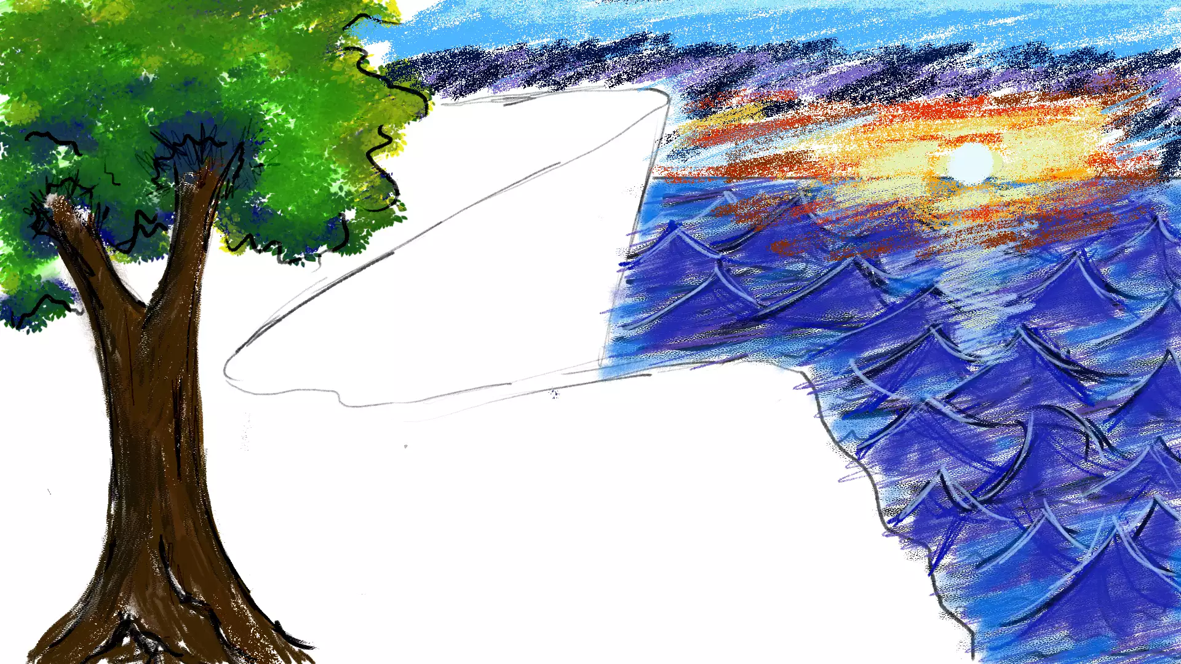

Lab Code Output:
